REPORT Z.

PARAMETERS NUM1 TYPE I DEFAULT 10. "cannot give value for parameter

PARAMETERS NUM2 TYPE I.

DATA RES TYPE I.

RES = NUM1 + NUM2.

WRITE: 'The Addition of ', Num1, 'And', Num2, 'is', Res.

Execute the program.

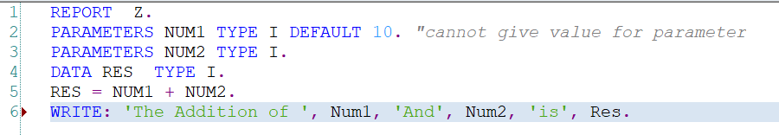

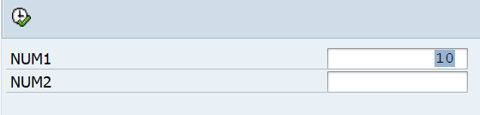

Now we want to change the parameter labels.

In the above activated program, Goto -> Text Elements->Selection Texts

Enter the text against the parameter names as shown below. Activate the Text Element.

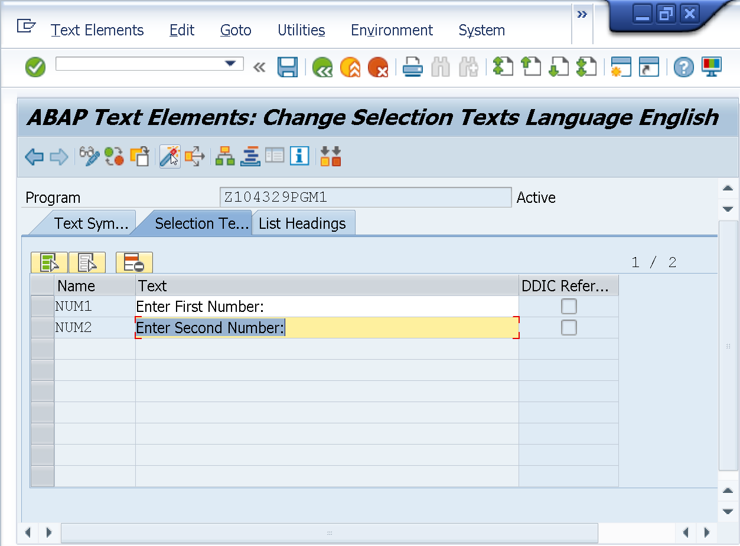

Execute the program.

Observe the Selection Text.

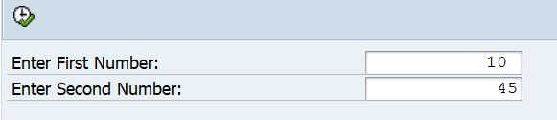

Execute the program to see the result as shown below.

